SQL implementation

Name of student

Name of professor

University

Course

Date

For this particular activity, the implementation of the SQL process and procedures is based on the real estate application that is under implementation. The table object classes include:

* Tenants class
* Partners class
* Crime class
* Payments class
* Transactions class
* Location class
* Estate class

The ERD diagrams are based on the derivation of the following keys:

|  |  |  |  |
| --- | --- | --- | --- |
| Tenant_id | Tenant_name | Tenant_status | Crime_id |
| PRIMARY KEY (PK) |  |  | FOREIGN KEY (FK) |
|  |  |  |  |

**Partners table**

|  |  |  |  |
| --- | --- | --- | --- |
| Patner_id | Patner_name | Patner_estate | Estate_id |
| PRIMARY KEY (PK) |  |  | FOREIGN KEY (FK) |
|  |  |  |  |

Crime table;

|  |  |  |
| --- | --- | --- |
| Crime_id | Crime_name | Crime_location |
| PRIMARY KEY (PK) |  | FOREIGN KEY (FK) |
|  |  |  |

Payments class

|  |  |  |  |
| --- | --- | --- | --- |
| Payment_id | Payment_name | Payment_amount | Transaction_id |
| PRIMARY KEY (PK) |  |  | FOREIGN KEY (FK) |

Trnsanctions class

|  |  |  |  |
| --- | --- | --- | --- |
| Trsnaction_id | Trsnaction_name | Transaction_amount | Payment_id |
| PRIMARY KEY(PK) |  |  | FOREIGN KEY (FK) |
|  |  |  |  |

Location class

|  |  |  |  |
| --- | --- | --- | --- |
| Location_id | Location_name | Estate_id | Location_status |
| PRIMARY KEY(PK) |  | FOREIGN KEY (FK) |  |
|  |  |  |  |

**Estate class**

|  |  |  |  |
| --- | --- | --- | --- |
| Estate_id | Estate_name | Location_id | Estate_status |
| PRIMARY KEY(PK) |  | FOREIGN KEY (FK) |  |
|  |  |  |  |

And the associated EDR diagrams for this as are follows:

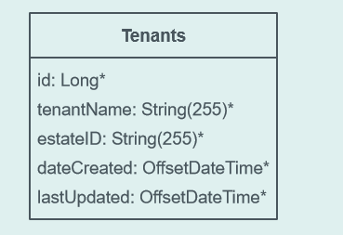

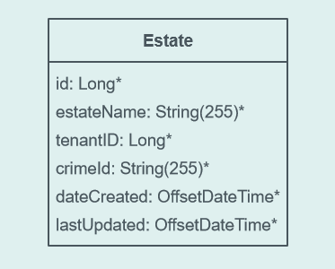

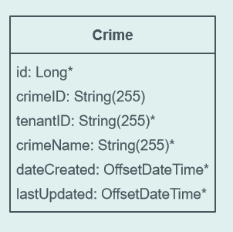’

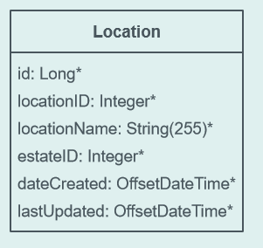

**The relationship mapping is as follows:**

